
CAR RENTAL SYSTEM

Object-oriented analysis and design (OOAD)
HAMMAD WASEEM 11224
Uzair Ahmed 11226 Sir Sohail Imran

Table of Contents
- 1.0 Certification of Completion.
- 2.0 Brief introduction to Car Rental System.
  - 2.1 Objectives
  - 2.2 Scope
  - 2.3 Levels of Access
  - 2.4 Problem Statement
  - 2.5 Methodology
- 3.0 System and Software Design
  - 3.1 Implementation and Unit Testing
  - 3.2 System Testing
- 4.0 Software Development Tools.
- 5.0 Project Diagrams:
  - 5.1 Use Case
  - 5.2 Activity Diagram
  - 5.3 Class Diagram
  - 5.4 Sequence Diagram
  - 5.5 Collaboration Diagram
  - 5.6 State Chart Diagram
- 6.0 Proposed System Screenshots
- 7.0 Login Credentials
- 8.0 URL’s of Project.

1.0 Certification of Completion:
This is to certify that this report embodies the project work done by full hard work of all project members. We completed all requirements of our project. Our project title is Car Rental System

2.0 Brief introduction to Car Rental System
CAR RENTAL SYSTEM (CRS) is a web-based system for a company that rents out cars. This system enables the company to make their services available to the public through the internet and also keep records about their services.
The world has become a place where there is a lot of technological development; where every single thing done physically has been transformed into a computerized form. Nowadays, people’s activities have been transformed into work done by computerized systems. One of which is the main target of this project is about Car Rental System. The system of renting cars exist back in the previous years when people rent cars for personal reasons. Car renting is essential to many peoples’ plan to travel or move from one place to another for business purposes, tour, and visit or holidays, for these reasons Car renting is very helpful.
The [8] starting point of Car renting is unknown as said by Thomas Pretty; he also mentioned that many believe that Joe Saunders was the first man to start a Car renting company. According to Thomas Pretty, charges were calculated with the help of a mileage tracking device. Many people became interested in the Car rental business and hence got involved. Car renting became more popular as years pass by. Today Car renting services is found all over the world, especially in developed and developing countries. To make this service more popular and accessible to the public it has been transformed into a web-based system and connected to the internet where everyone can be able to have access to it.

2.1 Objectives:

The main objectives of this project are:
· To develop a web-based system that will help manage the business transactions of car renting.
· To help in advertising the car rental services of a company, through the availability of the system online.

2.2 Scope:
The scope of this project is as follows:

· The car rental system to keep detailed records of both the cars and the customers, the duration they rent a car as well as the type of car they rent.
· The system will be mainly designed for small a company that renders its car rental services to customers.
· The system will have the ability to generate and print invoices for each successful transaction.

2.3 Levels of Access:
The system will have two levels of access:
· The administrator
· Customer
· Dealer
2.4 Problem Statement:

The problem with some of the current systems is that:
· Based on observations, some small companies already have a car rental system that is not a web-based application. This is a limitation that gives the capability to store customers’ details, but at the same time they cannot make their services more available to the public through the internet, they rather make use of posters to advertise their services to the public. These types of companies can overcome these problems by switching to the web-based application of their type of system.
· They also make use of phone call reservations which are also limited to many features as compared to a web-based system. For example, a customer may make a phone call reservation for a particular car, but when he/she comes to pick up the car, he/she might turn not to like the car; this could be because the customer could not see a sample picture of the car he/she wants to rent

2.5 Methodology:
The Iterative Waterfall Model is the development methodology that has been used in this project to develop the CRS. This [1] [2] [18] Model is derived from the evolution of the traditional Waterfall Model. It consists of five phases, which include; the Requirement and Definition, System and Software Design, Implementation and Testing, System testing, Operation, and maintenance. Each of these phases is repeated if an error is discovered, this enables the correction of errors before moving to the next phase. Figure 1.1 below represents the Iterative Waterfall Model for this project, and each of the phases is explained accordingly.

3.0 System and Software Design:

Using the requirement definition as a foundation, the requirements are divided into software and hardware. This is called system design. Software design is the process of representing the functions of each software system in a manner that may readily be transformed into one or more computer programs. Use case diagrams, class diagrams, sequence diagrams, entity-relationship diagrams (ERD), and data dictionaries are used at this level to represent the system design.

3.1 Implementation and unit testing:

During this stage, the software design is released as a set of programs. Unit testing involves verifying that each unit is working according to the specification of the customer.

3.2 System Testing:

The individual programs or units are integrated and tested as a complete system to ensure that the software requirements have been met as specified by the end-users. After testing has been completed, the software system is delivered to the customer.

4.0 Software Development Tools:

Visual studio 2019 (MVC)
The frontend is created in MVC 5
SQL 2019
SQL 2019 is used for database
Microsoft Word
Microsoft word are used for report
Somee.com
Somee can be used for deployment the project
Creately.com
Creately.com can be used for making UML Diagrams
Visual Paradigm
VisualParadigm.com can also be used for making UML Diagrams
GitHub
github.com can be used for saving your project states

5.0 Project Diagrams:
A use case is a written description of how users will perform tasks on your website. It outlines, from a user's point of view, a system's behaviour as it responds to a request. Each use case is represented as a sequence of simple steps, beginning with a user's goal and ending when that goal is fulfilled

5.1 Use case Diagram:
In this diagram admin is connected with the ovels which shows that what the dealer, System and Customer can access.

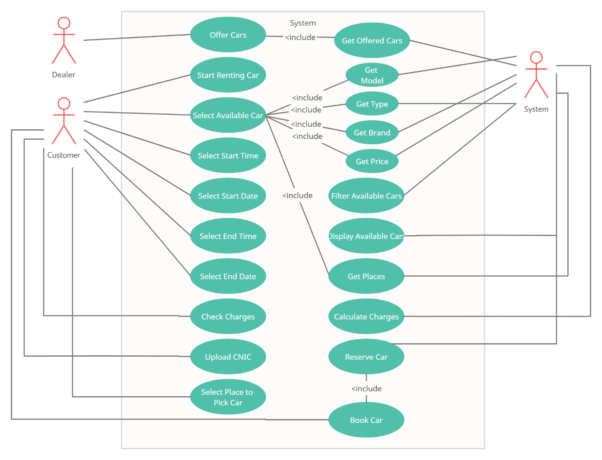

5.3 Activity Diagram:
Advertisements. Activity diagram is another important diagram in UML to describe the dynamic aspects of the system. Activity diagram is basically a flowchart to represent the flow from one activity to another activity. The activity can be described as an operation of the system.
This diagram shows the how the admin, dealer, Customer is using or shows the behaviour

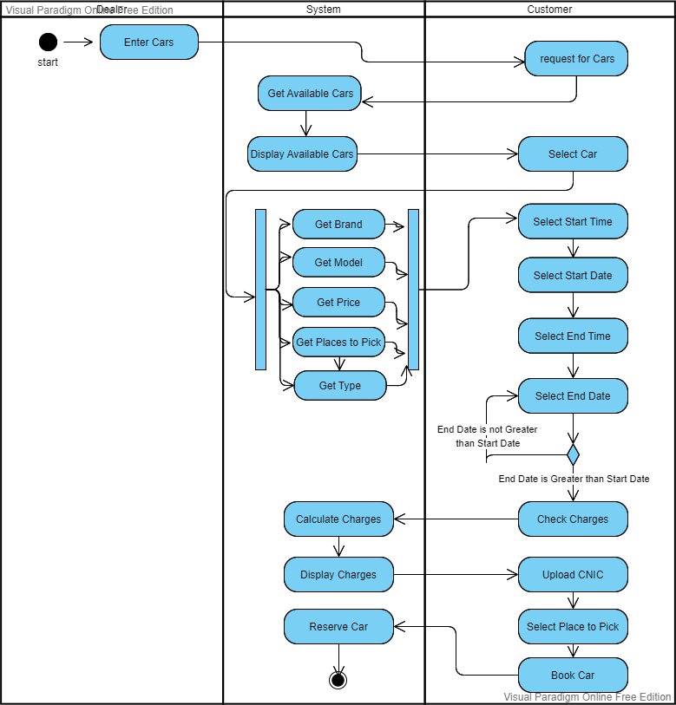

5.4 Class Diagram:

Class diagrams are the main building block in object-oriented modeling. They are used to show the different objects in a system, their attributes, their operations and the relationships among them.

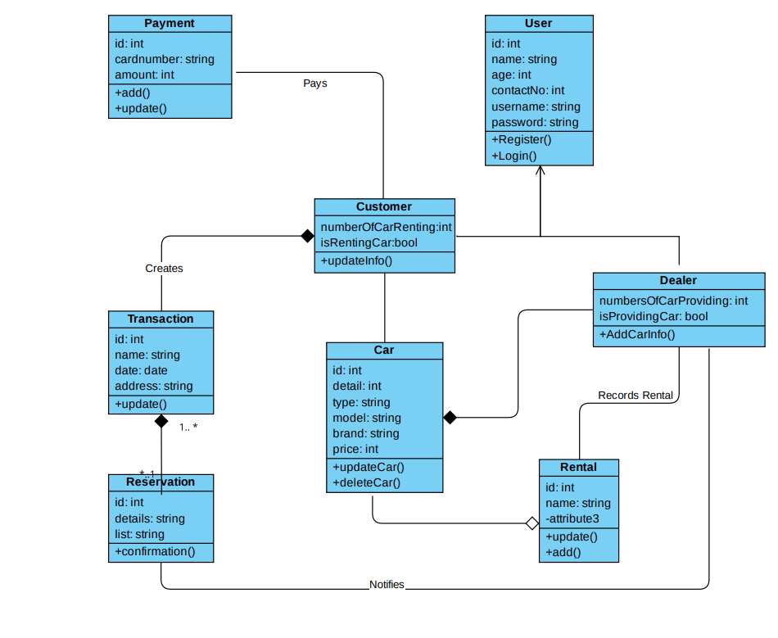

5.5 Sequence Diagram:

A sequence diagram is a type of interaction diagram because it describes how—and in what order—a group of objects works together.
These diagrams are used by software developers and business professionals to understand requirements for a new system or to document an existing process.

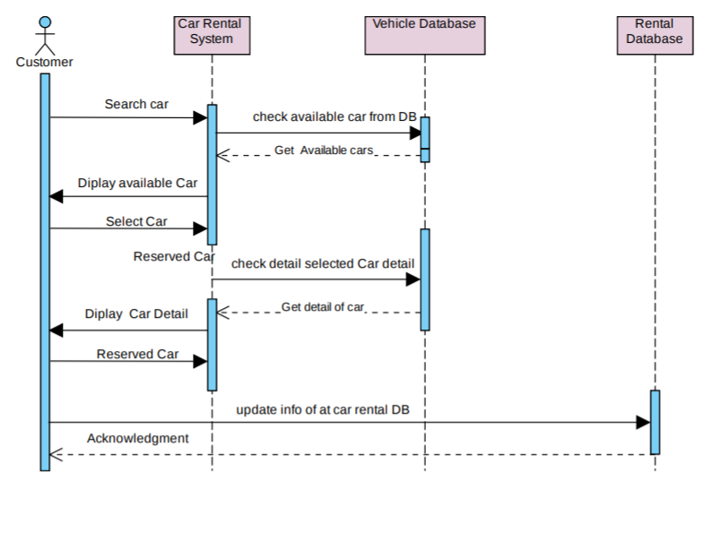

5.6 Collaboration Diagram:

A collaboration diagram describes a pattern of interaction among objects; it shows the objects participating in the interaction by their links to each other and the messages that they send to each other

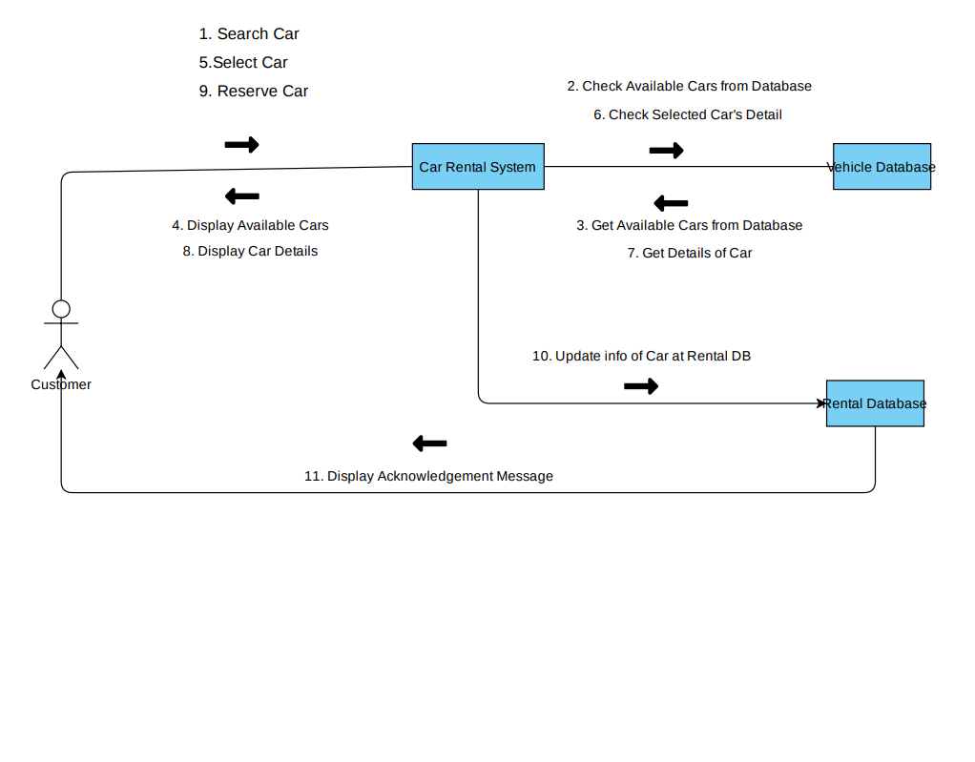

5.7 State Chart:

State chart diagram is one of the five UML diagrams used to model the dynamic nature of a system. They define different states of an object during its lifetime and these states are changed by events.

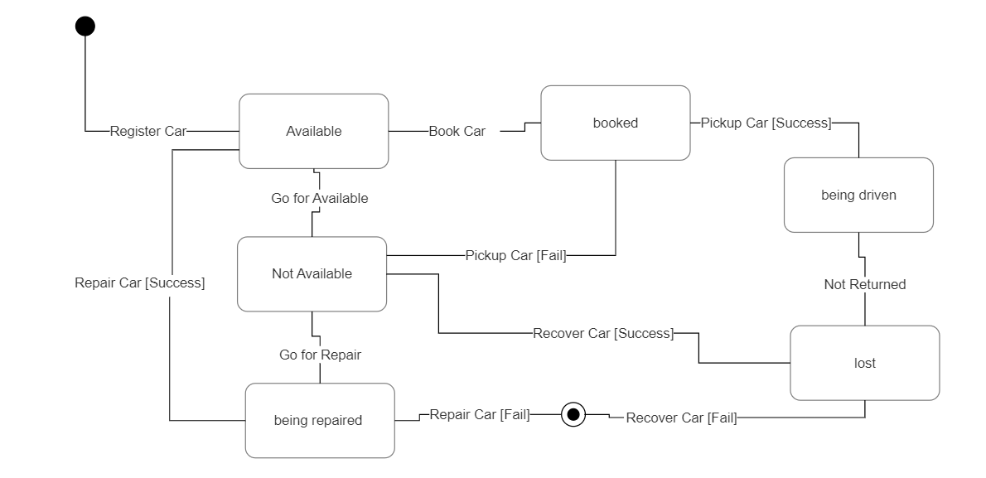

6.0 Proposed System Screenshots:
6.1 Log-in page:

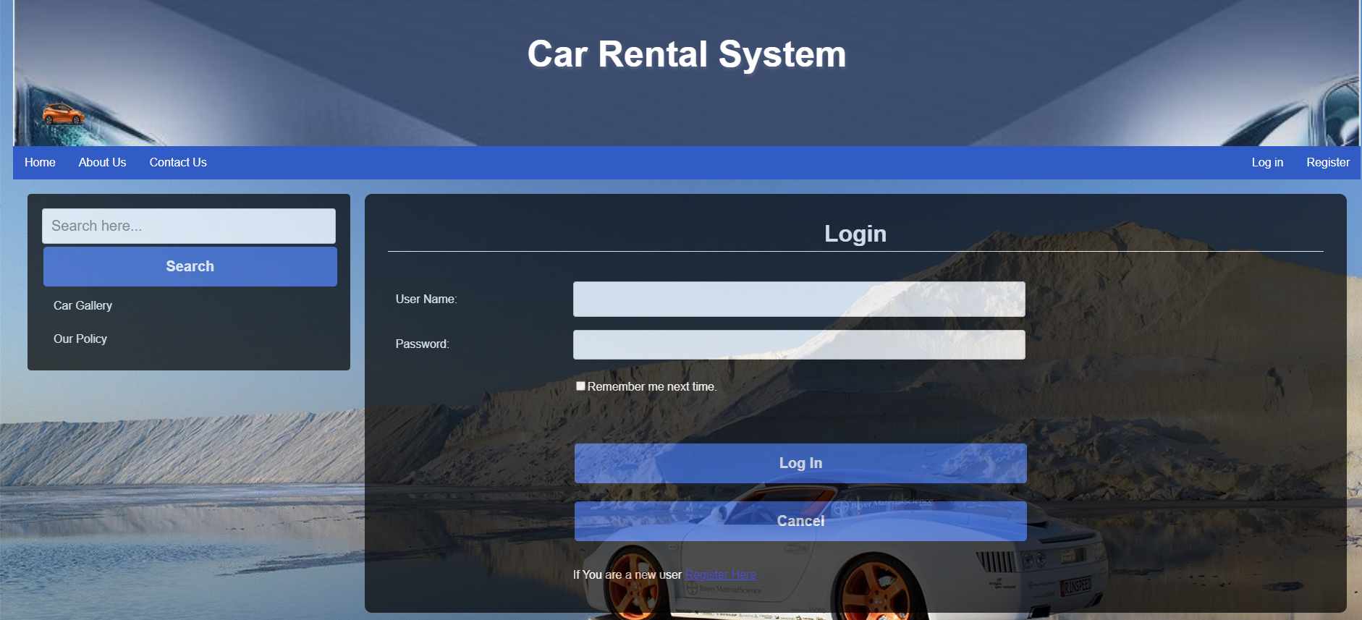

6.2 Register page:

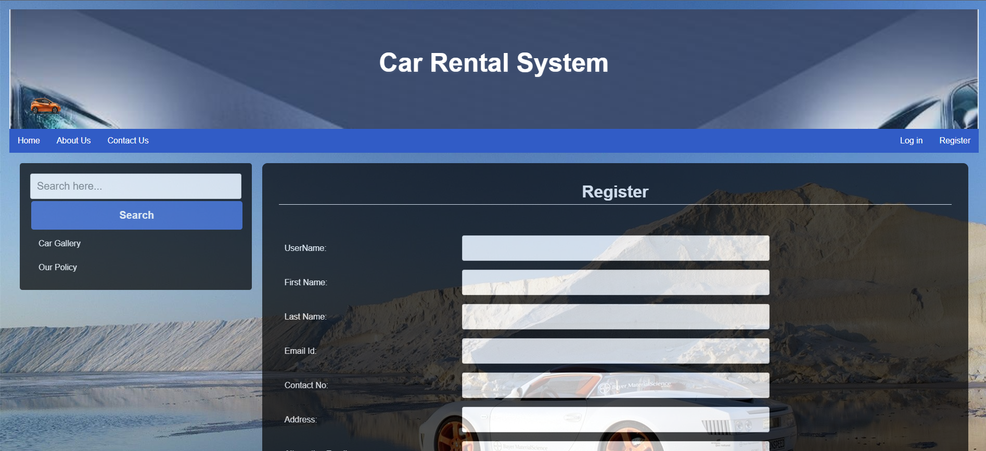
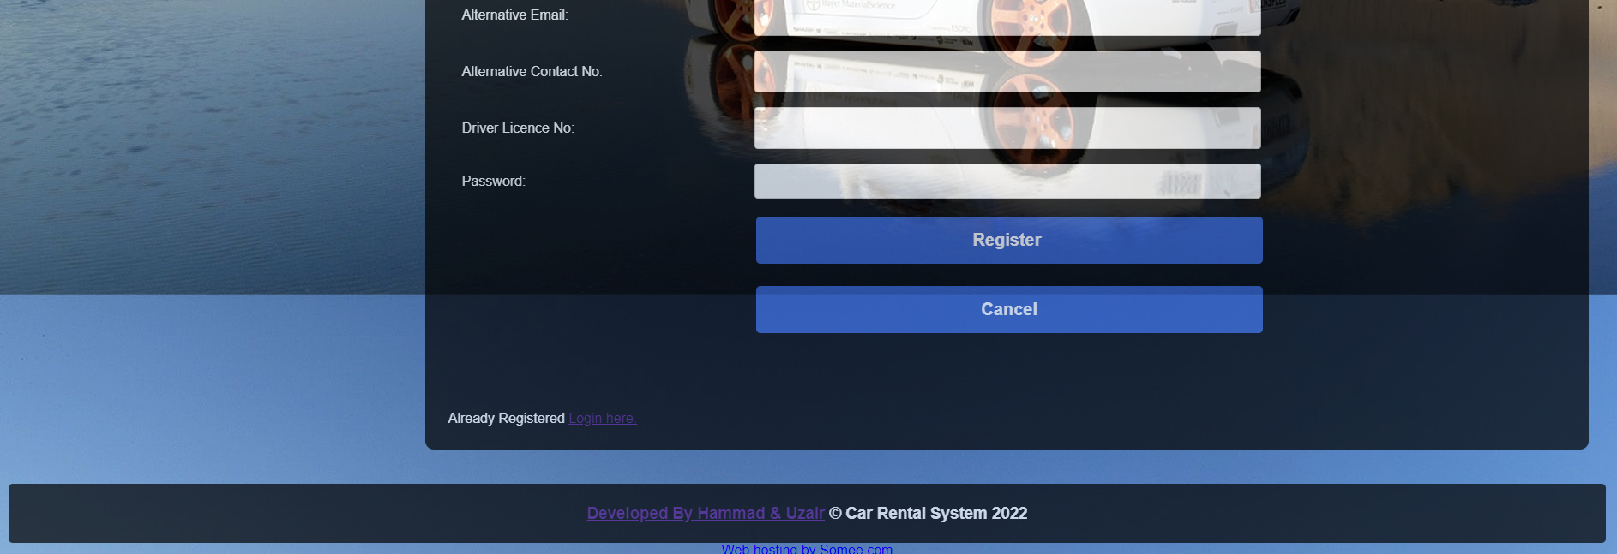

6.3 Home Page:

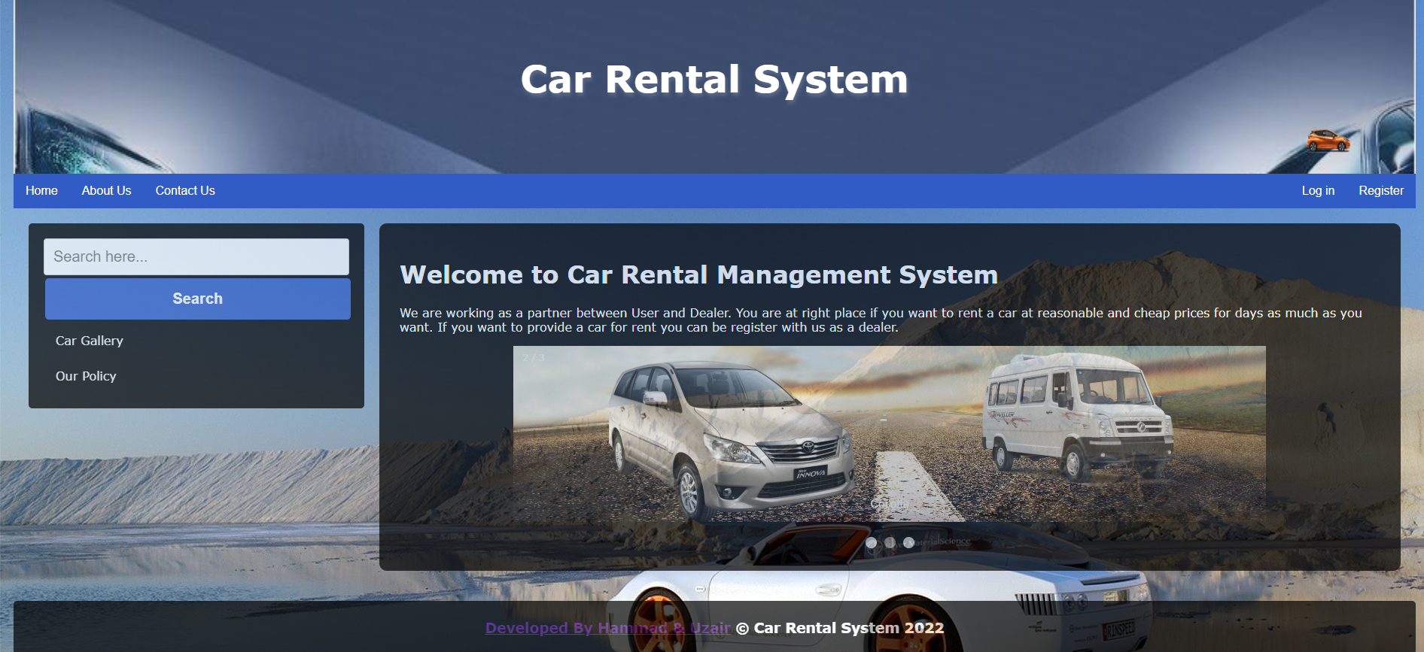

6.4 Rent Form:

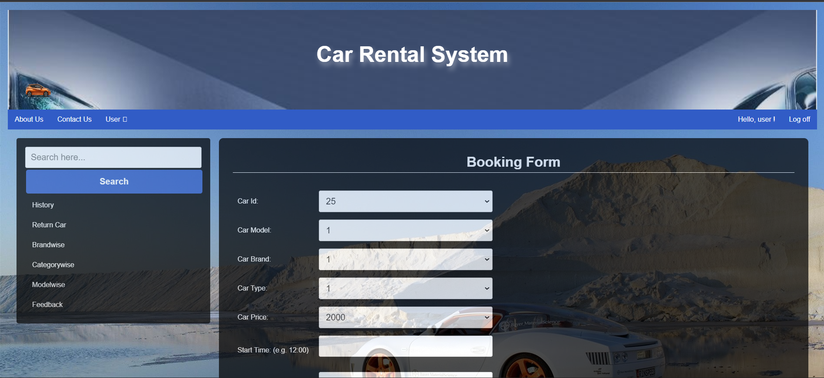
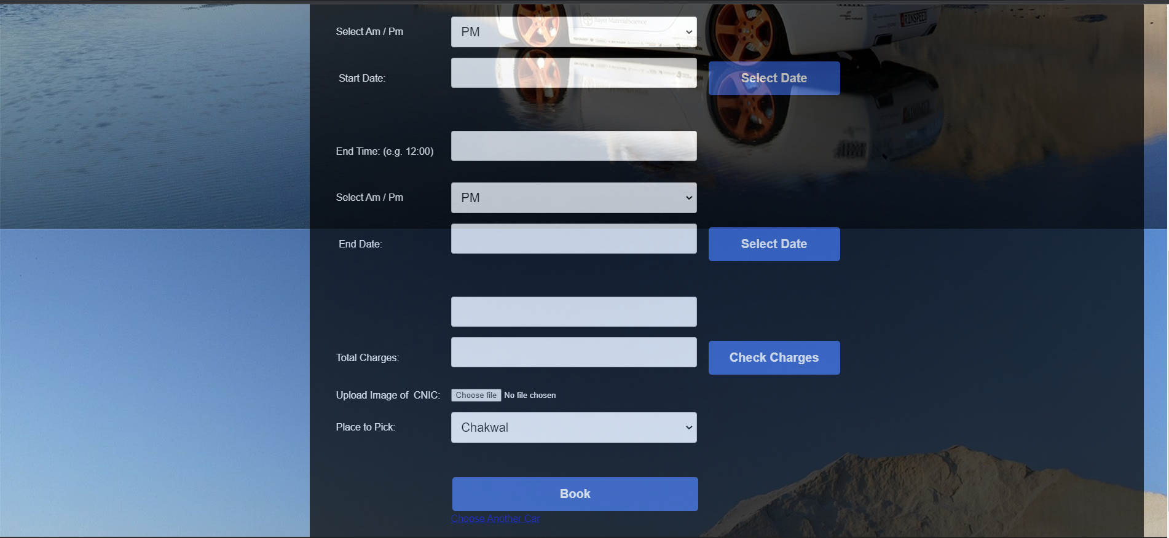

6.5 Return Car Form:

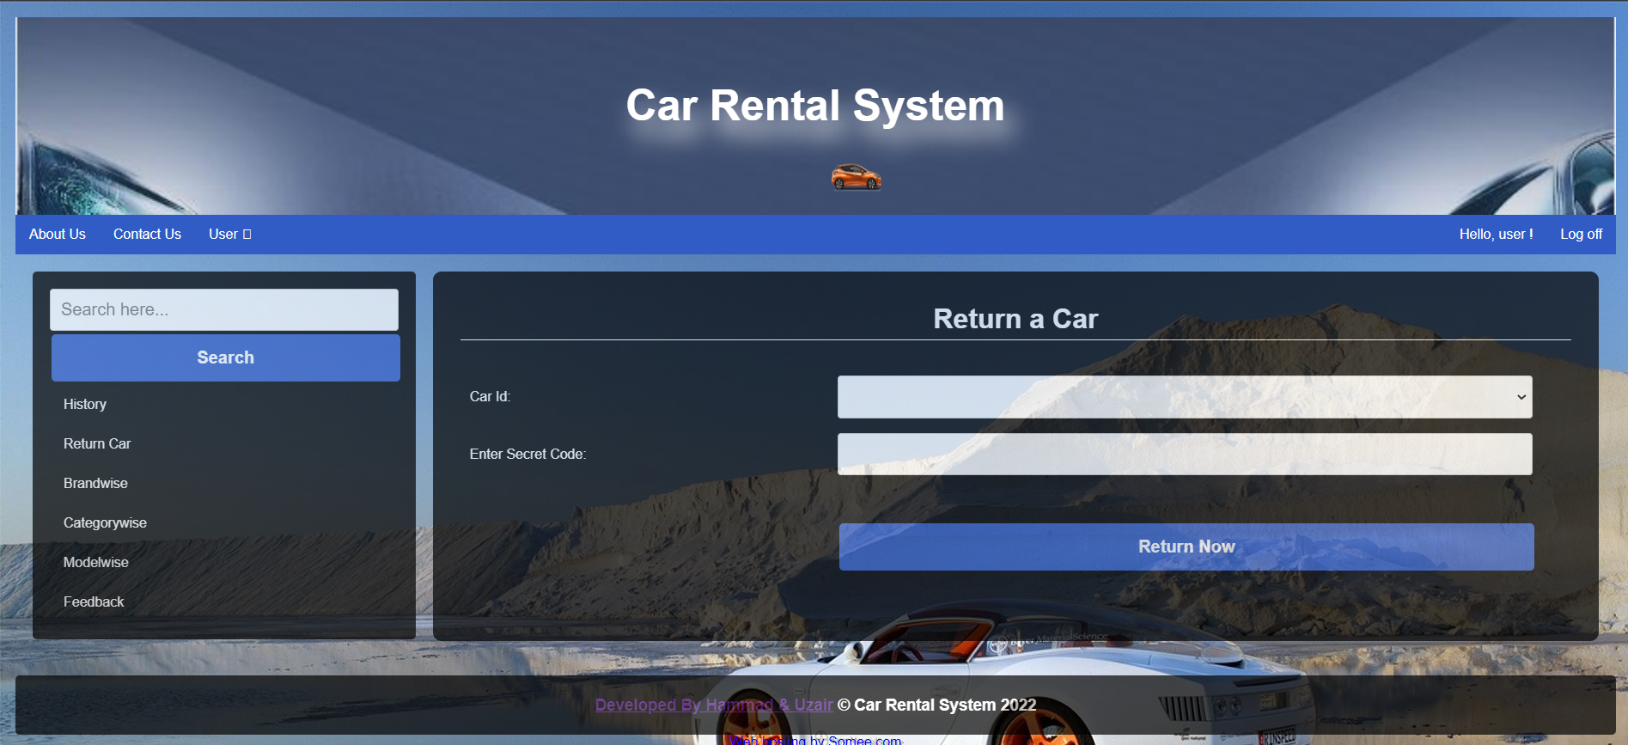

6.6 Feedback Form:

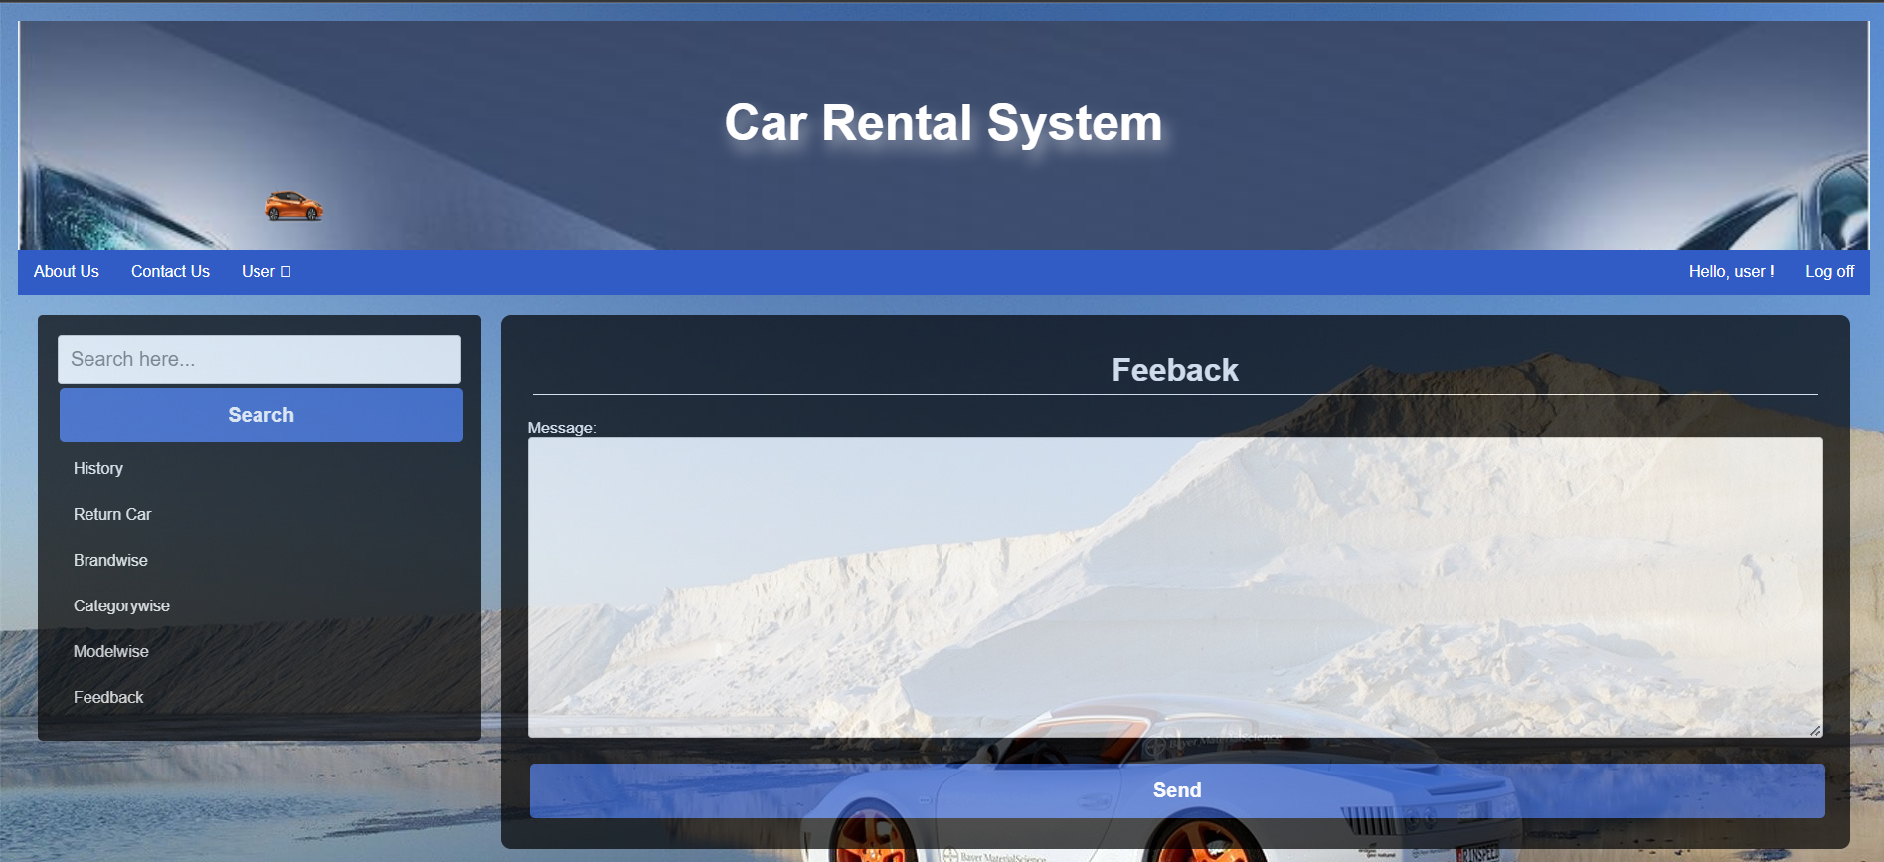

These attached screenshots are from customer view only if you want to see admin and dealer view. we are providing login credentials Below

7.0 Login Credentials:
ADMIN:
Username: admin
Password: admin
Customer:
Username: user
Password: codegainer
Dealer:
Username: dealer
Password: dealer
Accountant:
Username: Accountant
Password: accountant

8.0 URL’s of project:
Website Link:
http://rentacar.somee.com
GitHub Repository Link:
Hammad19/Car-Rental-System (github.com)

